15 November 2004

Version 1.0

Power distribution scheme for the Trigger L1 racks supplied from a regular electrical network in USA15

Wieslaw Iwanski

_____________________________________________

I. General description

Racks in USA15 are supplied from the Canalis system. Power for a single rack flows from Canalis via the individual Twido box (Fig1.) to a distribution chassis (Fig2.) installed on top of the rack.

A. Connection of racks to the Canalis system.

Canalis is a bar bus system supplying three phase power 400 V AC.

The Twido box is a module plugged-in directly into Canalis. It contains a main three phase switch protecting the electrical network from an overload from a rack side. By default this switch is remotely controlled and can cut off the power flowing to the rack on demand from the DCS side. It hosts also a Twido PLC which monitors relevant parameters and provides an optional remote control of 3 out of 4 output power connectors in a distribution chassis of the rack.

B. Distribution of power inside the rack.

The distribution chassis is a module installed on top of each rack, behind an air turbine. On its input, it is connected - via cables - to the Twido box and on its output it provides 4 output power connectors and a separate power cord to the turbine. All outputs are individually protected by local switches. Depending on requirements, the distribution chassis exists in four different configurations: standard or special single phase installations as well as standard or special three phase installations.
In a standard single phase installation all 4 output power connectors deliver single phase power but none of them is remotely controlled by the Twido box. Two output power connectors are installed on the phases R and S respectively, while the other two ones and the power cord to the turbine share the phase T. Each output power connector has a capacity of 16 A so that they can provide 14 kW of a total power to a single rack.
In a special single phase installation, three output power connectors – those installed on different phases – can be individually switched on/off remotely. The fourth one is not remotely controlled. In this case a total of a power is 10 kW on remotely controlled outputs plus 3 kW on not remotely controlled one.
Note: Remote control of the output connectors it is an option which is available only on request.
In a standard three phase installation, three output power connectors drive three phase power while the fourth one delivers the single phase power. The latter one as well as the powering cord to the turbine are installed on the phase The total power available on the output is 30 kW on three phase power connectors and 3 kW on the single phase one. None of the output connectors can be remotely switched on/off.
The special three phase installation is applied to the racks which require more three phase power than available in the standard one. None of the output power connectors can be remotely switched on/off.

It is assumed that users themselves distribute power from the output power connectors in the distribution chassis to the equipment inside the rack. For each rack containing the distribution chassis it will be delivered four 2 m long, one side open cables, each having on other side a plug matching the output connector.

C. Cooling of a rack.

Each rack comes with the cooling system consisting of the air turbine (top of the rack), at least one water-cooled heat exchanger (somewhere in the middle of equipment) and an air deflector (bottom line of equipment). All parts of the cooling system of the rack are ordered and will be delivered.

II. Scope of this specification

In this document are shown only racks belonging to particular sub-system and supplied – even in part - from a regular electrical network. Racks fed exclusively from UPS backed-up installation are not shown here and are subject of a separate document.

The Trigger L1 racks are located in USA15, in following places:

Level 1
row 2: columns 3 through 15 and 20 through 30
Level 2
row 2: columns 4 through 12 and 16 through 29

There are 47 racks in total, all are of 52Ua type.

III. Specification

Y.3-2.A1: TrigL1 Spare Rack (No power required)

Output connectors | 0
Current | 0
Turbine | Not installed
Optional remote control | Not requested
Power requested | 0 kW
Power delivered | 0 kW

Y.4-2.A1: TrigL1 Spare Rack (No power required)

Output connectors | 0
Current | 0
Turbine | Not installed
Optional remote control | Not requested
Power requested | 0 kW
Power delivered | 0 kW

Y.5-2.A1: TrigL1 Spare Rack (No power required)

Output connectors | 0
Current | 0
Turbine | Not installed
Optional remote control | Not requested
Power requested | 0 kW
Power delivered | 0 kW

Y.6-2.A1: TrigL1 TGC ROD Rack (Standard single phase installation)

Output connectors | 4 x Harting Q50 (230 V AC single phase)
Output connectors |  | #1: R phase and N
Output connectors |  | #2: S phase and N
Output connectors |  | #3: T phase and N
Output connectors |  | #4: T phase and N
Current | 16A in each connector
Turbine | Installed
Optional remote control | Not requested
Power requested | 3 kW
Power delivered | 14 kW

Y.7-2.A1: TrigL1 TGC ROD Rack (Standard single phase installation)

Output connectors | 4 x Harting Q50 (230 V AC single phase)
Output connectors |  | #1: R phase and N
Output connectors |  | #2: S phase and N
Output connectors |  | #3: T phase and N
Output connectors |  | #4: T phase and N
Current | 16A in each connector
Turbine | Installed
Optional remote control | Not requested
Power requested | 3 kW
Power delivered | 14 kW

Y.8-2.A1: TrigL1 TGC ROD Rack (Standard single phase installation)

Output connectors | 4 x Harting Q50 (230 V AC single phase)
Output connectors |  | #1: R phase and N
Output connectors |  | #2: S phase and N
Output connectors |  | #3: T phase and N
Output connectors |  | #4: T phase and N
Current | 16A in each connector
Turbine | Installed
Optional remote control | Not requested
Power requested | 3 kW
Power delivered | 14 kW

Y.9-2.A1: TrigL1 Muon End Cap Rack (Standard single phase installation)

Output connectors | 4 x Harting Q50 (230 V AC single phase)
Output connectors |  | #1: R phase and N
Output connectors |  | #2: S phase and N
Output connectors |  | #3: T phase and N
Output connectors |  | #4: T phase and N
Current | 16A in each connector
Turbine | Installed
Optional remote control | Not requested
Power requested | 4 kW
Power delivered | 14 kW

Y.10-2.A1: TrigL1 Muon End Cap Rack (Standard single phase installation)

Output connectors | 4 x Harting Q50 (230 V AC single phase)
Output connectors |  | #1: R phase and N
Output connectors |  | #2: S phase and N
Output connectors |  | #3: T phase and N
Output connectors |  | #4: T phase and N
Current | 16A in each connector
Turbine | Installed
Optional remote control | Not requested
Power requested | 4 kW
Power delivered | 14 kW

Y.11-2.A1: TrigL1 Muon End Cap Rack (Standard single phase installation)

Output connectors | 4 x Harting Q50 (230 V AC single phase)
Output connectors |  | #1: R phase and N
Output connectors |  | #2: S phase and N
Output connectors |  | #3: T phase and N
Output connectors |  | #4: T phase and N
Current | 16A in each connector
Turbine | Installed
Optional remote control | Not requested
Power requested | 4 kW
Power delivered | 14 kW

Y.12-2.A1: TrigL1 Muon End Cap Rack (Standard single phase installation)

Output connectors | 4 x Harting Q50 (230 V AC single phase)
Output connectors |  | #1: R phase and N
Output connectors |  | #2: S phase and N
Output connectors |  | #3: T phase and N
Output connectors |  | #4: T phase and N
Current | 16A in each connector
Turbine | Installed
Optional remote control | Not requested
Power requested | 4 kW
Power delivered | 14 kW

Y.13-2.A1: TrigL1 Muon End Cap Rack (Standard single phase installation)

Output connectors | 4 x Harting Q50 (230 V AC single phase)
Output connectors |  | #1: R phase and N
Output connectors |  | #2: S phase and N
Output connectors |  | #3: T phase and N
Output connectors |  | #4: T phase and N
Current | 16A in each connector
Turbine | Installed
Optional remote control | Not requested
Power requested | 4 kW
Power delivered | 14 kW

Y.14-2.A1: TrigL1 Muon to CTP Intf Rack (Standard single phase installation)

Output connectors | 4 x Harting Q50 (230 V AC single phase)
Output connectors |  | #1: R phase and N
Output connectors |  | #2: S phase and N
Output connectors |  | #3: T phase and N
Output connectors |  | #4: T phase and N
Current | 16A in each connector
Turbine | Installed
Optional remote control | Not requested
Power requested | 5 kW
Power delivered | 14 kW

Y.15-2.A1: TrigL1 CTP Rack (Standard single phase installation)

Output connectors | 4 x Harting Q50 (230 V AC single phase)
Output connectors |  | #1: R phase and N
Output connectors |  | #2: S phase and N
Output connectors |  | #3: T phase and N
Output connectors |  | #4: T phase and N
Current | 16A in each connector
Turbine | Installed
Optional remote control | Not requested
Power requested | 5 kW
Power delivered | 14 kW

Y.20-2.A1: TrigL1 TTC Rack (Standard single phase installation)

Output connectors | 4 x Harting Q50 (230 V AC single phase)
Output connectors |  | #1: R phase and N
Output connectors |  | #2: S phase and N
Output connectors |  | #3: T phase and N
Output connectors |  | #4: T phase and N
Current | 16A in each connector
Turbine | Installed
Optional remote control | Not requested
Power requested | 7.5 kW
Power delivered | 14 kW

Y.21-2.A1: TrigL1 TTC Rack (Standard single phase installation)

Output connectors | 4 x Harting Q50 (230 V AC single phase)
Output connectors |  | #1: R phase and N
Output connectors |  | #2: S phase and N
Output connectors |  | #3: T phase and N
Output connectors |  | #4: T phase and N
Current | 16A in each connector
Turbine | Installed
Optional remote control | Not requested
Power requested | 7.5 kW
Power delivered | 14 kW

Y.22-2.A1: TrigL1 TTC Rack (Standard single phase installation)

Output connectors | 4 x Harting Q50 (230 V AC single phase)
Output connectors |  | #1: R phase and N
Output connectors |  | #2: S phase and N
Output connectors |  | #3: T phase and N
Output connectors |  | #4: T phase and N
Current | 16A in each connector
Turbine | Installed
Optional remote control | Not requested
Power requested | 7.5 kW
Power delivered | 14 kW

Y.23-2.A1: TrigL1 TTC Rack (Standard single phase installation)

Output connectors | 4 x Harting Q50 (230 V AC single phase)
Output connectors |  | #1: R phase and N
Output connectors |  | #2: S phase and N
Output connectors |  | #3: T phase and N
Output connectors |  | #4: T phase and N
Current | 16A in each connector
Turbine | Installed
Optional remote control | Not requested
Power requested | 7.5 kW
Power delivered | 14 kW

Y.24-2.A1: TrigL1 RPC Rack (Standard single phase installation)

Output connectors | 4 x Harting Q50 (230 V AC single phase)
Output connectors |  | #1: R phase and N
Output connectors |  | #2: S phase and N
Output connectors |  | #3: T phase and N
Output connectors |  | #4: T phase and N
Current | 16A in each connector
Turbine | Installed
Optional remote control | Not requested
Power requested | 10 kW
Power delivered | 14 kW

Y.25-2.A1: TrigL1 RPC Rack (Standard single phase installation)

Output connectors | 4 x Harting Q50 (230 V AC single phase)
Output connectors |  | #1: R phase and N
Output connectors |  | #2: S phase and N
Output connectors |  | #3: T phase and N
Output connectors |  | #4: T phase and N
Current | 16A in each connector
Turbine | Installed
Optional remote control | Not requested
Power requested | 10 kW
Power delivered | 14 kW

Y.26-2.A1: TrigL1 RPC Rack (Standard single phase installation)

Output connectors | 4 x Harting Q50 (230 V AC single phase)
Output connectors |  | #1: R phase and N
Output connectors |  | #2: S phase and N
Output connectors |  | #3: T phase and N
Output connectors |  | #4: T phase and N
Current | 16A in each connector
Turbine | Installed
Optional remote control | Not requested
Power requested | 10 kW
Power delivered | 14 kW

Y.27-2.A1: TrigL1 RPC Rack (Standard single phase installation)

Output connectors | 4 x Harting Q50 (230 V AC single phase)
Output connectors |  | #1: R phase and N
Output connectors |  | #2: S phase and N
Output connectors |  | #3: T phase and N
Output connectors |  | #4: T phase and N
Current | 16A in each connector
Turbine | Installed
Optional remote control | Not requested
Power requested | 10 kW
Power delivered | 14 kW

Y.28-2.A1: TrigL1 RPC Rack (Standard single phase installation)

Output connectors | 4 x Harting Q50 (230 V AC single phase)
Output connectors |  | #1: R phase and N
Output connectors |  | #2: S phase and N
Output connectors |  | #3: T phase and N
Output connectors |  | #4: T phase and N
Current | 16A in each connector
Turbine | Installed
Optional remote control | Not requested
Power requested | 10 kW
Power delivered | 14 kW

Y.29-2.A1: TrigL1 RPC Rack (Standard single phase installation)

Output connectors | 4 x Harting Q50 (230 V AC single phase)
Output connectors |  | #1: R phase and N
Output connectors |  | #2: S phase and N
Output connectors |  | #3: T phase and N
Output connectors |  | #4: T phase and N
Current | 16A in each connector
Turbine | Installed
Optional remote control | Not requested
Power requested | 10 kW
Power delivered | 14 kW

Y.30-2.A1: TrigL1 TileCal Discr Rack (Standard single phase installation)

Output connectors | 4 x Harting Q50 (230 V AC single phase)
Output connectors |  | #1: R phase and N
Output connectors |  | #2: S phase and N
Output connectors |  | #3: T phase and N
Output connectors |  | #4: T phase and N
Current | 16A in each connector
Turbine | Installed
Optional remote control | Not requested
Power requested | 7.5 kW
Power delivered | 14 kW

Y.4-2.A2: TrigL1 Spare Rack (No power required)

Output connectors | 0
Current | 0
Turbine | Not installed
Optional remote control | Not requested
Power requested | 0 kW
Power delivered | 0 kW

Y.5-2.A2: TrigL1 Spare Rack (No power required)

Output connectors | 0
Current | 0
Turbine | Not installed
Optional remote control | Not requested
Power requested | 0 kW
Power delivered | 0 kW

Y.6-2.A2: TrigL1 Cal Rcvr Rack (Standard single phase installation)

Output connectors | 4 x Harting Q50 (230 V AC single phase)
Output connectors |  | #1: R phase and N
Output connectors |  | #2: S phase and N
Output connectors |  | #3: T phase and N
Output connectors |  | #4: T phase and N
Current | 16A in each connector
Turbine | Installed
Optional remote control | Not requested
Power requested | 1 kW
Power delivered | 14 kW

Y.7-2.A2: TrigL1 Cal Rcvr Rack (Standard single phase installation)

Output connectors | 4 x Harting Q50 (230 V AC single phase)
Output connectors |  | #1: R phase and N
Output connectors |  | #2: S phase and N
Output connectors |  | #3: T phase and N
Output connectors |  | #4: T phase and N
Current | 16A in each connector
Turbine | Installed
Optional remote control | Not requested
Power requested | 3 kW
Power delivered | 14 kW

Y.8-2.A2: TrigL1 Cal Rcvr Rack (Standard single phase installation)

Output connectors | 4 x Harting Q50 (230 V AC single phase)
Output connectors |  | #1: R phase and N
Output connectors |  | #2: S phase and N
Output connectors |  | #3: T phase and N
Output connectors |  | #4: T phase and N
Current | 16A in each connector
Turbine | Installed
Optional remote control | Not requested
Power requested | 3 kW
Power delivered | 14 kW

Y.9-2.A2: TrigL1 Patch panels Rack (No power required)

Output connectors | 0
Current | 0
Turbine | Not installed
Optional remote control | Not requested
Power requested | 0 kW
Power delivered | 0 kW

Y.10-2.A2: TrigL1 Preproc Rack (Standard single phase installation)

Output connectors | 4 x Harting Q50 (230 V AC single phase)
Output connectors |  | #1: R phase and N
Output connectors |  | #2: S phase and N
Output connectors |  | #3: T phase and N
Output connectors |  | #4: T phase and N
Current | 16A in each connector
Turbine | Installed
Optional remote control | Not requested
Power requested | 7 kW
Power delivered | 14 kW

Y.11-2.A2: TrigL1 Preproc Rack (Standard single phase installation)

Output connectors | 4 x Harting Q50 (230 V AC single phase)
Output connectors |  | #1: R phase and N
Output connectors |  | #2: S phase and N
Output connectors |  | #3: T phase and N
Output connectors |  | #4: T phase and N
Current | 16A in each connector
Turbine | Installed
Optional remote control | Not requested
Power requested | 7 kW
Power delivered | 14 kW

Y.12-2.A2: TrigL1 TileCal Patch panels Rack (No power required)

Output connectors | 0
Current | 0
Turbine | Not installed
Optional remote control | Not requested
Power requested | 0 kW
Power delivered | 0 kW

Y.16-2.A2: TrigL1 Cluster Proc Rack (Standard single phase installation)

Output connectors | 4 x Harting Q50 (230 V AC single phase)
Output connectors |  | #1: R phase and N
Output connectors |  | #2: S phase and N
Output connectors |  | #3: T phase and N
Output connectors |  | #4: T phase and N
Current | 16A in each connector
Turbine | Installed
Optional remote control | Not requested
Power requested | 5.4 kW
Power delivered | 14 kW

Y.17-2.A2: TrigL1 Cluster Proc Rack (Standard single phase installation)

Output connectors | 4 x Harting Q50 (230 V AC single phase)
Output connectors |  | #1: R phase and N
Output connectors |  | #2: S phase and N
Output connectors |  | #3: T phase and N
Output connectors |  | #4: T phase and N
Current | 16A in each connector
Turbine | Installed
Optional remote control | Not requested
Power requested | 5.4 kW
Power delivered | 14 kW

Y.18-2.A2: TrigL1 Jet/Energy Proc Rack (Standard single phase installation)

Output connectors | 4 x Harting Q50 (230 V AC single phase)
Output connectors |  | #1: R phase and N
Output connectors |  | #2: S phase and N
Output connectors |  | #3: T phase and N
Output connectors |  | #4: T phase and N
Current | 16A in each connector
Turbine | Installed
Optional remote control | Not requested
Power requested | 5.4 kW
Power delivered | 14 kW

Y.19-2.A2: TrigL1 Calo ROD Rack (Standard single phase installation)

Output connectors | 4 x Harting Q50 (230 V AC single phase)
Output connectors |  | #1: R phase and N
Output connectors |  | #2: S phase and N
Output connectors |  | #3: T phase and N
Output connectors |  | #4: T phase and N
Current | 16A in each connector
Turbine | Installed
Optional remote control | Not requested
Power requested | 6.8 kW
Power delivered | 14 kW

Y.20-2.A2: TrigL1 TileCal Patch panels Rack (No power required)

Output connectors | 0
Current | 0
Turbine | Not installed
Optional remote control | Not requested
Power requested | 0 kW
Power delivered | 0 kW

Y.21-2.A2: TrigL1 Preprocessor Rack (Standard single phase installation)

Output connectors | 4 x Harting Q50 (230 V AC single phase)
Output connectors |  | #1: R phase and N
Output connectors |  | #2: S phase and N
Output connectors |  | #3: T phase and N
Output connectors |  | #4: T phase and N
Current | 16A in each connector
Turbine | Installed
Optional remote control | Not requested
Power requested | 7 kW
Power delivered | 14 kW

Y.22-2.A2: TrigL1 Preprocessor Rack (Standard single phase installation)

Output connectors | 4 x Harting Q50 (230 V AC single phase)
Output connectors |  | #1: R phase and N
Output connectors |  | #2: S phase and N
Output connectors |  | #3: T phase and N
Output connectors |  | #4: T phase and N
Current | 16A in each connector
Turbine | Installed
Optional remote control | Not requested
Power requested | 7 kW
Power delivered | 14 kW

Y.23-2.A2: TrigL1 Patch panels Rack (No power required)

Output connectors | 0
Current | 0
Turbine | Not installed
Optional remote control | Not requested
Power requested | 0 kW
Power delivered | 0 kW

Y.24-2.A2: TrigL1 Calo Rcvr Rack (Standard single phase installation)

Output connectors | 4 x Harting Q50 (230 V AC single phase)
Output connectors |  | #1: R phase and N
Output connectors |  | #2: S phase and N
Output connectors |  | #3: T phase and N
Output connectors |  | #4: T phase and N
Current | 16A in each connector
Turbine | Installed
Optional remote control | Not requested
Power requested | 3 kW
Power delivered | 14 kW

Y.25-2.A2: TrigL1 Calo Rcvr Rack (Standard single phase installation)

Output connectors | 4 x Harting Q50 (230 V AC single phase)
Output connectors |  | #1: R phase and N
Output connectors |  | #2: S phase and N
Output connectors |  | #3: T phase and N
Output connectors |  | #4: T phase and N
Current | 16A in each connector
Turbine | Installed
Optional remote control | Not requested
Power requested | 3 kW
Power delivered | 14 kW

Y.26-2.A2: TrigL1 Calo Rcvr Rack (Standard single phase installation)

Output connectors | 4 x Harting Q50 (230 V AC single phase)
Output connectors |  | #1: R phase and N
Output connectors |  | #2: S phase and N
Output connectors |  | #3: T phase and N
Output connectors |  | #4: T phase and N
Current | 16A in each connector
Turbine | Installed
Optional remote control | Not requested
Power requested | 3 kW
Power delivered | 14 kW

Y.27-2.A2: TrigL1 Spare Rack (No power required)

Output connectors | 0
Current | 0
Turbine | Not installed
Optional remote control | Not requested
Power requested | 0 kW
Power delivered | 0 kW

Y.28-2.A2: TrigL1 Spare Rack (No power required)

Output connectors | 0
Current | 0
Turbine | Not installed
Optional remote control | Not requested
Power requested | 0 kW
Power delivered | 0 kW

Y.29-2.A2: TrigL1 Spare Rack (No power required)

Output connectors | 0
Current | 0
Turbine | Not installed
Optional remote control | Not requested
Power requested | 0 kW
Power delivered | 0 kW

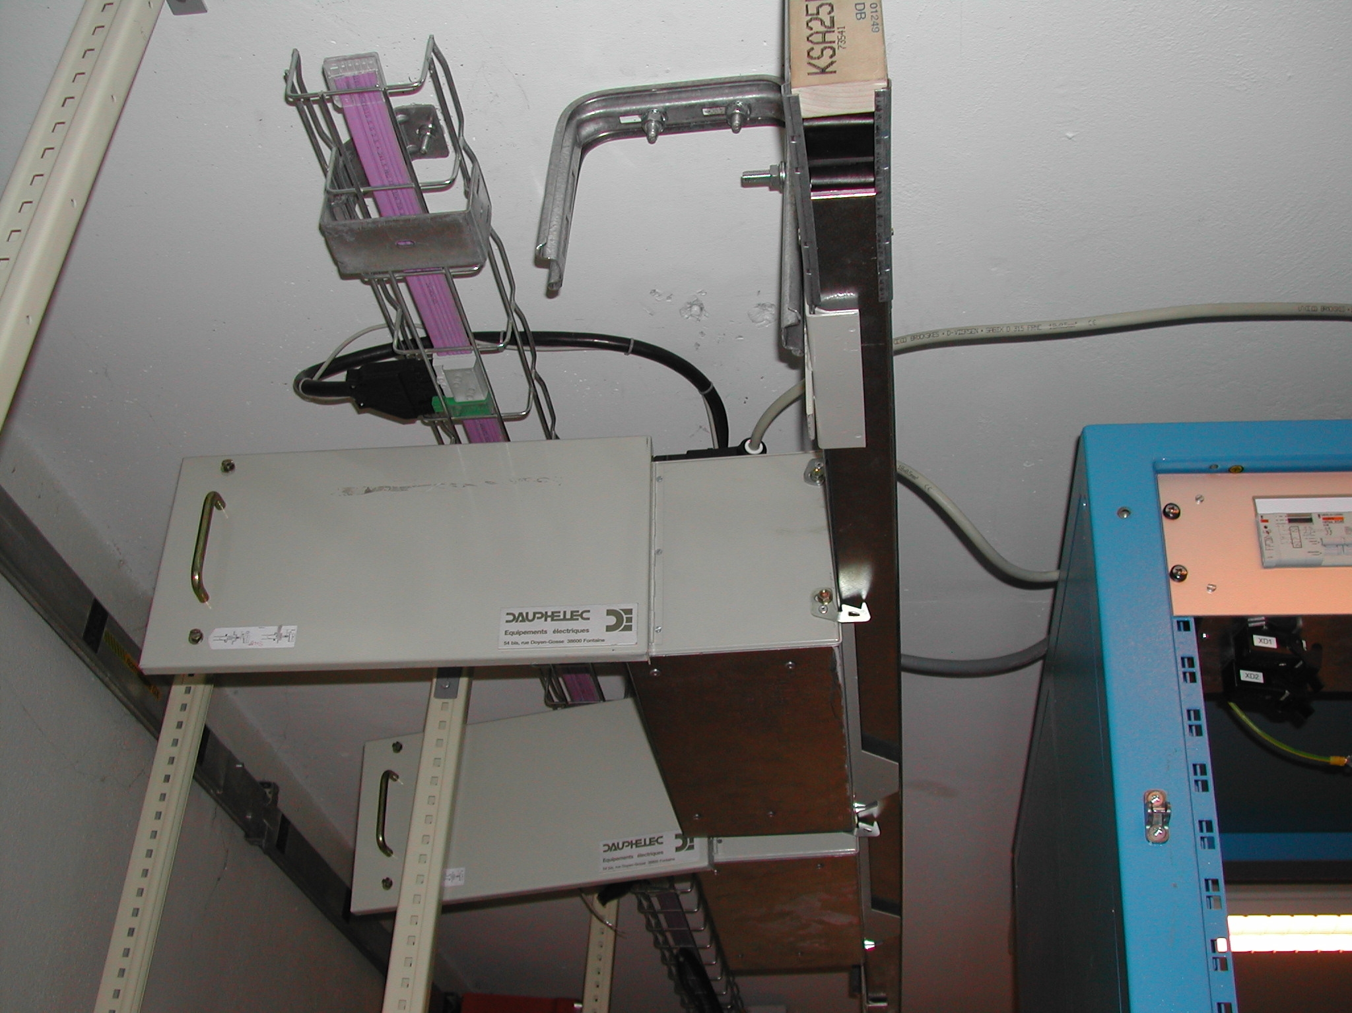

Fig1. Two Twido boxes plugged into the Canalis bar bus

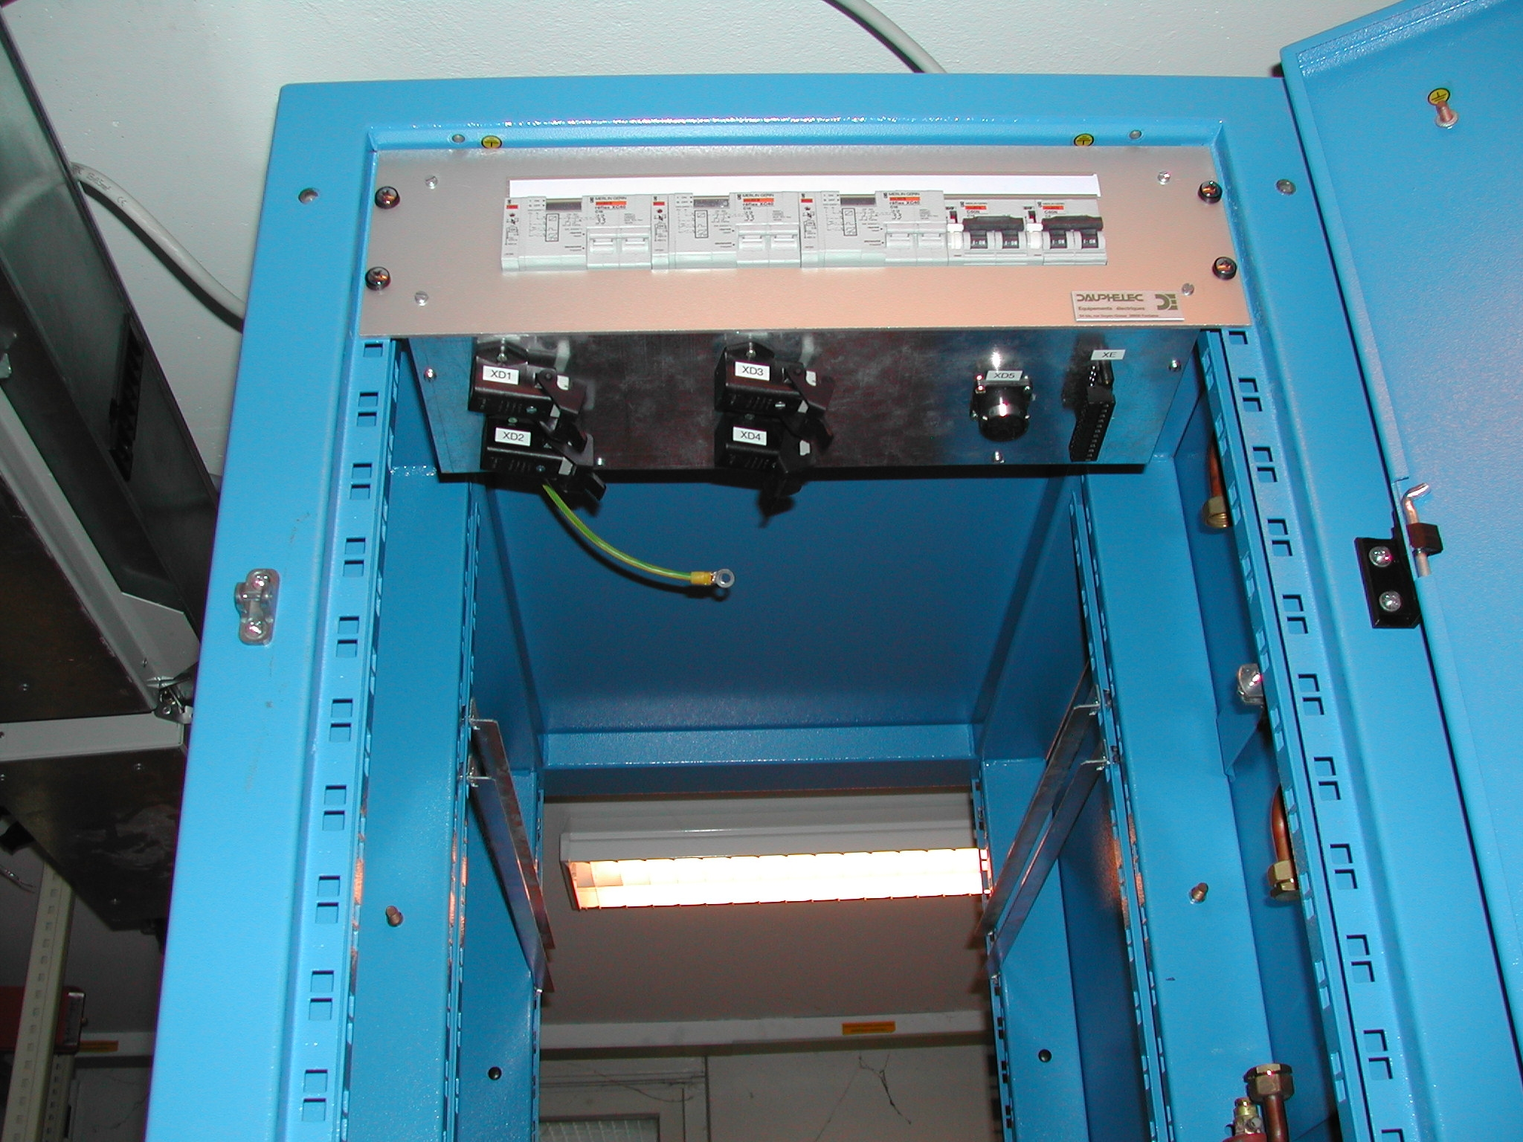

Fig2. Distribution chassis mounted on top of the rack (rear view). Four output connectors and round connector for powering the turbine seen on the bottom side of the chassis

